Rabbi Matisyahu Salamon zal-Passed away on 22 Tevet 5784

Some personal recollections

I was privileged to interact with Rav Matisyahu during the years I studied at Gateshead, from 1970-74. He was the Mashgiach Ruchani of the yeshiva and he dealt with our spiritual welfare and any urgent religious crises we might be experiencing. His caring attitude was felt by all who approached him. He also gave shiurim on topics of religious improvement (mussar shmuessen) and also a very popular weekly shiur on the parsha on Friday mornings. He also held vaadim, which were small informal gatherings to discuss with specific groups any issue which they wanted to discuss. I was part of a vaad of the more ‘modern’ boys, who had come to the yeshiva after A levels, at the age of 18+.One such vaad was used to discuss the issues of growing up in a mixed society, as many of us had been active in youth groups which were mixed. Rav Matisyahu did not shy away from his views and in this instance he quoted the pasuk we say every day:

בַּחוּרִ֥ים וְגַם־בְּתוּל֑וֹת זְ֝קֵנִ֗ים עִם־נְעָרִֽים׃
‘youths and maidens alike,
old and young together.’

to prove the point that old and young should be’ together’ whereas the young boys and girls should be separated. Although we may not have totally accepted his view, he spoke with great clarity and sincerity and this had an influence on me until today.
Tefilla
He was an outstanding Baal Tefilla and was the Baal Musaf in the yeshiva for Rosh Hashana and Yom Kippur. His nusach was truly electrifying and when he broke down crying in the preamble to Musaf(Hineni) it is a moment I will never forget. He also had a tremendous ability as an orator, and this was already the case in his younger years and remained well into the move to Lakewood.His speeches at conventions would be a highlight of the event.I once asked him as to how do the Americans deal with his very pronounced northern UK accent. He responded with a big smile and told me he thinks they find him ‘cute’. This sense of humor was already present during my days in Gateshead and I have always felt that this is a required element for any great Rav to have a true influence on others.

Personal questions.
I had a very interesting discussion with him as a result of an essay written by Rabbi Lamm zal of YU, whose book ‘The Royal Reach’ came out in 1970. In the book Rabbi Lamm maintains that the midrash of Mt. Sinai being held over the heads of the Jewish people at Matan Torah, was not meant to be taken literally. Rabbi Lamm explained it as a metaphor for not having free choice at the time, as represented by a ‘mountain which might crash down on them at any moment, unless they accept the Torah’. I asked Rav Matisyahu about this approach and got into a very interesting discussion of when to take Midrashim literally or not.His opinion was that when the Midrash is explaining a pasuk, it is to be taken literally, as in the case here where the expression ‘under the mountain’ is being explained. I wrote to Rabbi Lamm to ask for his sources for his approach and he sent back a whole list of commentaries to back up his view. I felt as if I was standing between ‘ 2 mountains’ in this discussion and the argument was purely leshem shamayim in every aspect.
Another memorable quote was in regard to the emergence of Chabad during the late 60’s and early 70’s. Rav Matisyahu told me that when Chabad is working on behalf of yiddishkeit, there is nothing really to compare. But when it is ‘lubavitchkeit’, such as messianic overtones and over adoration of the Rebbe, then one must be careful not to get involved with these aspects of the movement.

As I have tried to convey, the influence of Rav Matisyahu was very great. I would not call him my ‘Rav Muvhak’(rabbi par excellence) as in later years I moved away from the pure yeshiva world into a more academic and less ‘yeshivish’ approach to Jewish studies. However this does not diminish in any way the feeling of hakarat hatov I have for him, in his amazing ability to convey the pure word of Torah.
My son had the privilege of meeting him at Camp Hasc, which he came to visit for a number of years. Rav Matisyahu commented that Camp Hasc is the nearest place on earth to Gan Eden in everything that is done there. I am sure that he is now in his special place in Gan Eden. He once quoted from his rebbe, Rav Elya Lopian, the question of how to understand the concept of ‘bet din shel maalah’. He explained that every generation produces leaders , who when they pass away become part of this heavenly court. They can advocate on behalf of the generation because they lived in that generation. I believe Rav Matisyahu has joined this special court. May he be able to bring favorable judgements for us all and help to finalize the coming of Mashiach speedily in our days.

Rabbi Ian Shaffer Modiin Israel 22Tevet 5784
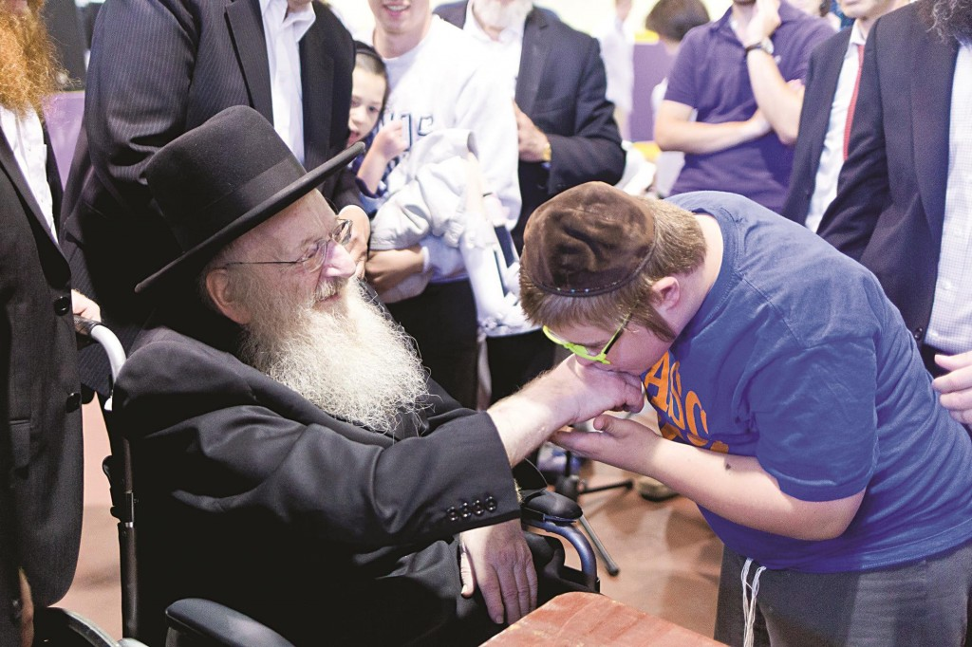
A beautiful photo of Rav Matisyahu zal at Hasc in 2014

