Jealousy Rots
Envy can Redeem

by

Rabbi Eliyahu Safran

Yaakov set up a monument over her grave; it is the monument of Rachel’s grave until today
- Breishit 35:20

When we are informed that Yaakov “set up a monument over her grave” it seems superfluous to add, “It is the monument of Rachel’s grave until today.” Why the repetition? As we observe the yahrzeit of my grandfather, Rav Bezalel Ze’ev Shafran on 14th Kislev, his explanation on a remarkable passage in Masechet Shabbat [152b] affords us clarity.
The Talmud relates of some workers digging on land belonging to Rav Nachman. In their labors, they happened upon a grave, disturbing the dead man’s peace. They were frightened by the man’s shriek from within the grave and, running in fear, went to inform Rav Nachman that, “a deceased man scolded us!” Hearing this news, Rav Nachman hurried with the workers to the grave. There, he leaned toward the grave and inquired as to the deceased man’s name.
“I am Achai son of Yoshiya.”
Rav Nachman looked back at the cowering workmen and then faced the grave. “Didn’t Rav Meri teach that even the bodies of the tzadikim will disintegrate in their graves?” He asked. “How is it that your body did not disintegrate?”
“Who is Rav Meri? I don’t know who he is.”
“You may not know who Rav Meri is but surely you are familiar with Koheleth, ‘…and the dust returns to the earth as it was.’ (12:2)
“Whoever taught you the posuk from Koheleth clearly did not teach you the posuk from Mishlei, ‘U’rkav atzamot – the rotting of the bones – kin’aa – envy.’ (14:30) That is, he who lives with jealousy in his life will turn to dust when he dies, but he who bears no jealousy, his bones will not disintegrate.
“Now, the posuk in Koheleth speaks to the majority of people who conduct their lives driven by jealousy but when I was alive, I did not bear jealousy in my heart and so my bones did not rot.”
Rav Nachum was much impressed with the explanation. Indeed, the Talmud concludes the passage with him reaching out and touching Achia’s body - chaziye d’is bei meshasha and finding that it was whole; even the flesh had not rotted.
Jealousy eats at the essence of our being. Thinkers, religious and otherwise, have noted its destructive, corrosive influence through the ages. William Penn wrote that, “The jealous are troublesome to others, but a torment to themselves.
It eats at us as we live. What’s more, it causes us to rot after we are in the grave.
But my grandfather taught that there could be a positive side to jealousy, to envy. When we are jealous, we want things we should not. However, it is possible to be envious of a fellow’s kindness, his sensitivity, his decency, understanding, knowledge and diligence. In other words, to envy these positive attributes, we might be motivated to attain those same positive attributes for ourselves. That type of envy, may well enhance one’s behavior and serve as a motivator for self-improvement.
“Let not your heart envy sinners” (Mishlei 23:17). Don’t be jealous of the wicked who seem to prosper. Don’t be tempted to follow in their footsteps, but rather Mishlei teaches, be envious of the righteous, of those “Who fear HaShem”.

Such envy is commendable and will enhance one’s life and midos. That is the ultimate meaning of the Talmudic expression, kina’as soferim tarbe chochma – Envy of the wise shall increase wisdom.

With this wise perspective and understanding of the nuance between jealousy and envy, my grandfather turned his attention to the posuk, “Yaakov set up a monument over her grave” – this matzevah, this monument, is set on her actual burial place. Of course, what’s the point? Because it is about Rachel that the Torah tells us that (after seeing that she did not bear children to Yaakov), “… Rachel became envious of her sister.” (30:1) It is because of this jealousy that we may suspect that her bones disintegrated and her body became as the dust of the earth, without leaving even a trace of her essence. If that were so then the monument Yaakov erected stands over nothing more than a clump of earth. But that is not the case. Such a jealousy is that which we know in our own mundane lives. If the posuk had ended with that statement, perhaps such a suspicion would be justified. But the posuk repeats, “it is the monument of Rachel’s grave until this day.” It is matzevas kevuras Rachel – the grave containing the actual remains of Rachel; not mere clumps of earth. Her grave holds her actual body. This is actually her place of burial. Not dust of the earth. Her bones did not rot ad ha’yom ha’zeh – until this very day.
So what then about the Torah’s report that Rachel was “envious of her sister?” Indeed she was envious! Envious of her sister’s good deeds! Rachel’s envy was of the type that is commendable; she was envious of good deeds, kindness, diligence and piety. She had the type of envy that increases more good and more achievements in the world. As Rashi states in Vayetze, She was envious of Leah’s good deeds. “She said, were she not more righteous than me, she wouldn’t be privileged to have so many children.” What incredible envy!
She recognized that the other attained goodness and riches because of their ma’asim tovim. Such kina’a is not only permitted, it is to be praised. It is a kina’a that results in good things.

I was mindful of my grandfather’s teaching when I thought of a situation involving a dear friend of mine who passed away. Circumstances did not allow for his burial in Israel, his chosen resting place, immediately after his passing. In accordance with halacha, he was buried locally and conditionally. When circumstances will allow, his remains would be transferred to their final resting place.
A year and a half passed.
The difficult task of exhuming the body was undertaken by a specialized Chevra Kadisha. The process is difficult for all involved, particularly the family which “relives” the sadness and grief of the death.
When the body had been removed from the local grave, one of the man’s sons – who had not been at graveside but nearby – approached the man who did the actual removal of the body.
“How was my father?” he asked, his voice trembling. “What condition was he in?”
“He was in perfect shape,” he was told. “As if he had been placed in the grave only today.”
The son was relieved and astonished. “But it has been a year and a half?” he exclaimed.
The rosh of the Chevra Kadisha nodded gently. “Your father was never jealous.”
Indeed, knowing the man well, I can attest that that was true. Any envy he experienced was to build, increase and enhance all that was good in his long and blessed life. The Talmud story speaks not only to the righteous of old, not only of Rachel Imeinu, but to those who may well cross our own paths even today.
So taught my grandfather, of blessed memory.

* * *

Below is a translated excerpt from the essay, The Romanian Gaon by Harav Yechiel Yaakov Weinberg, the Sridei Eish, written about my grandfather, the Gaon Rabbi Bezalel Ze’ev Shafran z’l, rav of Bacau, Romania, author of Sh’elot U’tshuvot R’BAZ. He died on the 14th of Kislev 5690 (1930).
From among the few towered a Jew of physically modest stature – weak, thin, adorned in worn clothing, with a crushed hat upon his head – the Rabbi of Baku z'l, bearer of the totality of the beautiful Rabbinic ideology of the old generation, devout in his beliefs, guileless in his character, guardian of ancient traditions, and brother to everyone whose path he crossed.
He walked among us as a brother, seemingly of our generation. But when he spoke, it was immediately apparent that he was a Talmudic giant, a master of the complete Torah, with its immense literature and infinite ramifications.
Truly, I felt as if I was in the presence of one of the Rabbis of old, reincarnated in our generation. One of the Giants. One of the ancient greats to whom the Torah was an open scroll, a living repository of the enormous Rabbinic literature.
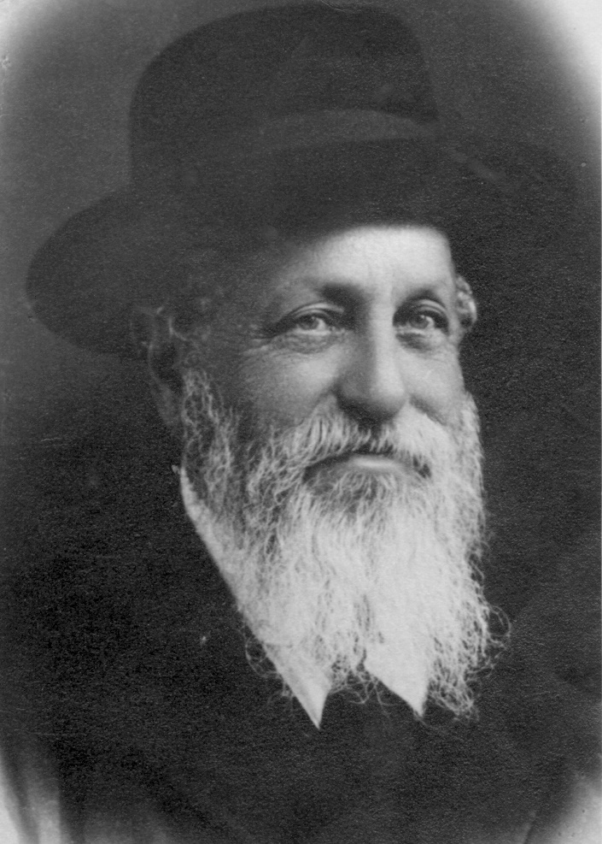
HaRav Bezalel Ze’ev Shafran Zt’l

