TEN MEANINGFUL MEDITATIONS ON THE

YOM KIPPUR MACHZOR 5780

**Contents**

Kol Nidrei Rabbi Daniel Feldman, Mitoch haOhel 1

Rav Soloveitchik, *Before Hashem*, 60-61 1

Tefillah of the Kohein Gadol 2

באונס: מחזור הגר"א 2

בבלי דעת: שיח יצחק 2

על חטא שחטאנו לפניך בוידוי פה 3

חדש עלינו שנה טובה, שיח צבי 3

ברוך שאמר 3

Al Tachlicheinu, ‘Teshuva’ 4

Mishna Berurah, Neilah 4

Unetaneh Tokeh, Rabbi Brander 5

Rabbi Andrew Markowitz

ram@shomrei-torah.org

Kol Nidrei Rabbi Daniel Feldman, Mitoch haOhel

Rav Soloveitchik, *Before Hashem*, 60-61

**ויקרא פרשת אחרי מות פרק טז**

(ל) כִּי בַיּוֹם הַזֶּה יְכַפֵּר עֲלֵיכֶם לְטַהֵר אֶתְכֶם מִכֹּל חַטֹּאתֵיכֶם **לִפְנֵי יְקֹוָק תִּטְהָרוּ:**

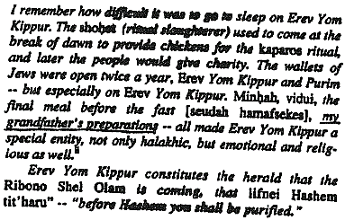

Tefillah of the Kohein Gadol

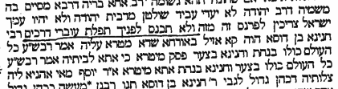

באונס: מחזור הגר"א

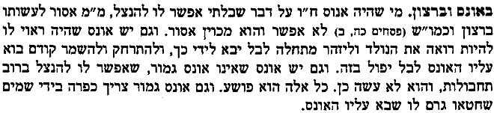

בבלי דעת: שיח יצחק

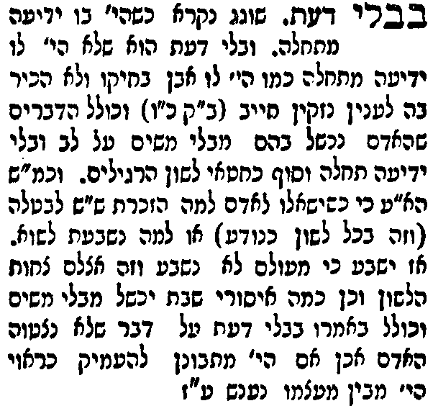

על חטא שחטאנו לפניך בוידוי פה

The Belzer Rebbe is quoted as giving the following mashal to present this idea: A villager goes to visit the big city. All of the sudden, a man starts riding around the city banging on a drum. The villager asks someone why someone is banging on a drum and he is told that there is a fire in the city. The villager then returns to his village and a few days later, a fire breaks out. The villager quickly grabs a drum and starts banging, but unfortunately, the whole village burns to the ground. Distraught, the villager returns to the city to ask why his drum didn't work. He is told that the drum doesn't put out the fire. It only alerts people that there is a fire and that they should help bring water. Similarly, we can recite vidui and beat our chest like a drum, but the purpose of the drum is to bring out the tears to put out the fire.

חדש עלינו שנה טובה, שיח צבי

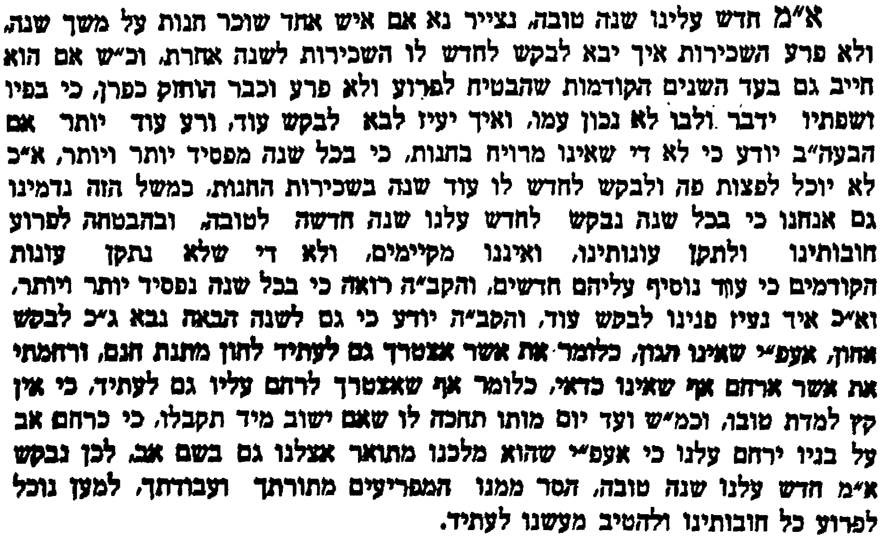

ברוך שאמר

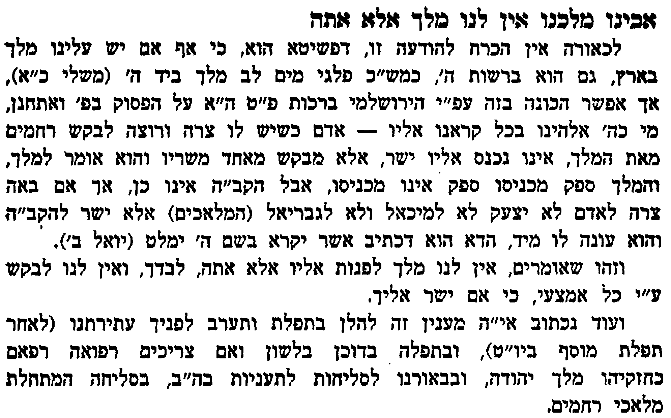

Al Tachlicheinu, ‘Teshuva’

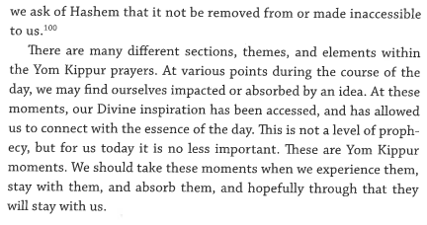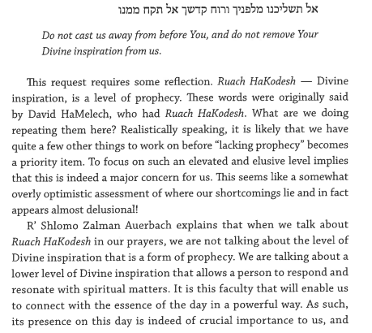

Mishna Berurah, Neilah

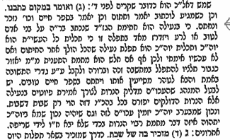

Unetaneh Tokeh, Rabbi Brander

