
The Prayer for the Welfare of the Government

For technical information regarding use of this document, press ctrl and click here
- Intro- This shiur outline will provide a halachic and historical perspective on the prayer for the government. Aside from the basic sources on the subject, there are many interesting historical tidbits in this packet.
- The Source for the prayer
  - Mishna Avos- R. Chanina states that one should pray for the welfare of the kingdom because if there is no fear of government, some people will take advantage of others. {1}
  - Kol Bo (unknown author around 14th-15th century) writes that in certain places there is a tradition of blessing the king after k'rias haTorah on Shabbos. {2}
  - R. David Avudraham (14th century) also writes that we bless the king before putting away the Torah on Shabbos. {3}
  - R. Chaim Benveniste (1603-1673) includes this as part of the prayers for Shabbos and specifically references the nusach of "HaNosen Teshua." {4}
    - This nusach is also found in a siddur printed in 1601. {5}
  - R. Yisrael Lipschitz (1782-1860) writes that the Mishna stresses to pray for the "malchus" as opposed to the melech, because the prayer is really for the ruling powers and not necessarily the king. Therefore, this prayer is appropriate even when there is a democracy. He also writes that anyone who is involved in communal affairs deserves the blessing. This is why we bless those who are osek b'tzorchei tzibbur together with the blessing for the government. {6}
- Specific Halachic Discussions about the prayer
  - R. Avraham Gombiner (Magen Avraham c. 1633-1683) writes that the intent of the line "v'yapil sonav, let his enemies fall" does not refer to the enemies of other nations because there are Jews in those other nations as well. Rather it means the enemies within the country who are trying to overthrow the country. {7}
    - R. Shmuel Loew (Machatzis HaShekel c. 1720-1806) adds that if you had Jews in two countries that are at war praying for the demise of its enemies, one of the prayers would have to be considered a tefillas shav. {8}
    - The line "v'yapil sonav does not appear in our text, but it did appear in a text written by the people of Asti to bless Napoleon after they were captured by the French in 1797. {9} It was also recited in America during WWII. {10}
  - Should the prayer be recited in Hebrew or in the vernacular?
    - R. Akiva Schlesinger (1838-1922) writes that one should not recite the prayer in the vernacular because if one believes that this prayer should be said, it should be no different than the prayers that we recite on our own behalf. {11}
    - R. Shem Tov Gagin (1884-1953) writes that the minhag in London and Amsterdam was to recite at least a portion of the prayer in the vernacular. {12}
  - What is the nature of the obligation to pray for the government?
    - Meiri (c.1249-1310) states that this is not just a recommendation. The prayer for the government is obligatory. {13}
    - R. Shimon Sofer (son of the Chasam Sofer) suggests that the beracha of "V'Lamalshinim" fulfills the requirement to pray for the malchus because we pray that the enemies of society are uprooted. {14}
    - Based on R. Sofer's comments, one can explain that this is the reason why we recite the tefillah for the government on Shabbos and Yom Tov. On these days, we don't recite "V'Lamalshinim" so a separate prayer takes its place.
    - It is interesting to note that in one of the biographies of R. Yisrael Salanter (1810-1883), it is recorded that he was davening in a shul on Shabbos that did not recite the prayer for the government. He then turned to the wall and recited it himself in order to fulfill the obligation to pray for the welfare of the government. {15}
- To What Extent was this Prayer Used as a Form of Appeasement?
  - This prayer was often cited as a proof that the Jews have no complaints against the government:
    - R. Shlomo Luria (1510-1574) writes in his introduction to Yam Shel Shlomo that any references in the book to non-Jews do not refer to today's non-Jews because we not only tolerate them, we pray for their welfare. {16}
  - R. Baruch Oberlander has an Article on the First Lubavitcher Rebbe's prayer for the government. There is an implication in the article that the Rebbe used the prayer as a means of appeasing the government.
  - R. Menasheh ben Israel (1604-1657) was instrumental in allowing Jews to return to England after many centuries of being banned from the country. One of the motivating factors was that his book Teshuas Yisrael was translated for Oliver Cromwell and it impressed him greatly. In Chapter 3, he discusses how Jews are always supporters of whatever government they reside in. [The text of his address to Oliver Cromwell in 1655 can be found here.]
  - R. Yosef Kapach suggests that the actual text of "HaNosen Teshua" must be a smokescreen: {19}
    - Both verses that are quoted in the text must be seen in context:
      - The first verse is an introduction to say that cannot place any trust in "b'nei nechar" {17}
      - The second verse is an introduction to say that the Almighty will destroy all armies. {18}
    - The reason why this text was chosen is that the Jews in each country were forced to recite a prayer in order to appease the government. They therefore chose a text that conveyed praise for the government, but knew that there was a hidden message.
    - R. Kapach suggests that this is why this prayer was never said in Yemen (until recent times) because they had an honest relationship with the ruler.
- Anecdotes
  - R. Moshe Sofer (1762-1839) kept a journal in the year 5569 (1809). At the outbreak of the War of the Fifth Coalition, the Jewish community held a special prayer service where they recited the prayer for the welfare of the government. {20}
  - The text of the prayer of HaNosen Teshua, which originated sometime in the 15th century, was transformed into the prayer for the welfare of Shabtai Tzvi. The references to the geulah were taken out and replaced with a request that he may be able to rebuild the Beis HaMikdash expeditiously. {21}
  - R. Avraham Borenstein (The Sokatchover Rebbe 1838-1910) had to run away from his rabanus because he didn't recite hanoseh teshuah. {22}
  - In 1910 the "Kollel Austreich Galitzia" in Yerushalayim, recited a Tefillah L'Shlom HaMalchus at the Kotel in honor of the 80th birthday of Franz Josef I. {23}
  - There is a story told of R. Mordechai HaChazan, who was the Chazzan in Mogilev for forty years. Towards the end of his career, the government decreed that all of the shuls must recite the prayer for the welfare of the government. R. Mordechai decided to resign from his position because he could not bring himself to recite the prayer. The gabbai took him to a din Torah before R. Chaim Berlin, who was the rav of the congregation. R. Chaim Berlin ruled that he may not step down and he must recite the prayer. That Shabbos, R. Mordechai had the choir for Yamim Noraim come and he told them to hum when he got to the words "yiromem v'yigadel etc." While they were humming he silently substituted those words with "ti'aker u'sishaber etc." The story can be found here.
  - Binyamin Kluger wrote a book titled "Min HaMakor" tracing the history of the Yishuv HaYashan through a collection of posters that were hung in Yerushalayim. We have included some of the posters declaring a prayer for the welfare of the government both under the Sultan of the Ottoman Empire (Mehmed V) and under Great Britain (at the end of the source sheet).
  - At the end of the source sheet is the text of two prayers for the USSR from a siddur printed in Moscow in 1956. It is interesting that they included the line "v'yapil soneha" in light of the aforemention comments of Magen Avraham. The USSR had Jewish enemies both within and without.
- For Further Reading:
  - Rev. Simeon Singer on the "Earliest Jewish Prayers for the English Sovereign," traces the history of the prayer with a focus on England. Click here to access.
  - Barry Schwartz, “Hanoten Teshua` The Origin of the Traditional Jewish Prayer for the Government,” Hebrew Union College Annual 57 (1986), pp.113-120. This article discusses the earliest source for the basic nusach "HaNosen Teshua." Click here to access the article.
  - Jonathan D. Sarna, "Jewish Prayers for the United States Government: A Study in the Liturgy of Politics and the Politics of Liturgy," in Ruth Langer & Steven Fine, eds., Liturgy in the Life of the Synagogue: Studies in the History of Jewish Prayer (Winona Lake, Indiana: Eisenbrauns, 2005), 205-224. The article traces the prayer for the welfare of the government through U.S. history. Click here to access the article.

- מש' אבות ג:ב
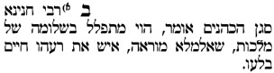
- כל בו ס' כ
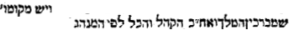
- אבודרהם סדר שחרית של שבת
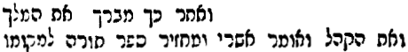
- שיירי כנסת הגדולה או"ח רפד:ה
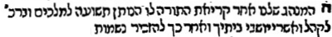
- סדור תפלות כל השנה כמנהג ק"ק ספרד (שס"א)
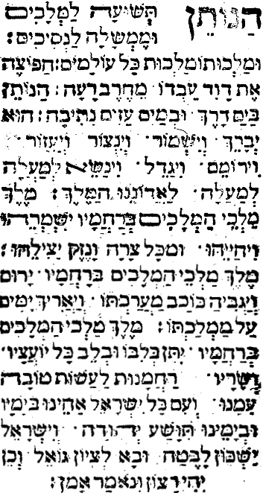
- תפארת ישראל אבות ג:ב
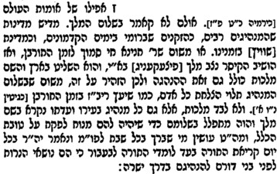
- מגן אברהם רפד:ז
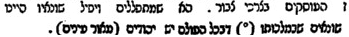
- מחצית השקל שם
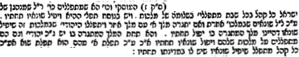
- סיני חוברת ק' (העתק מכתב יד)
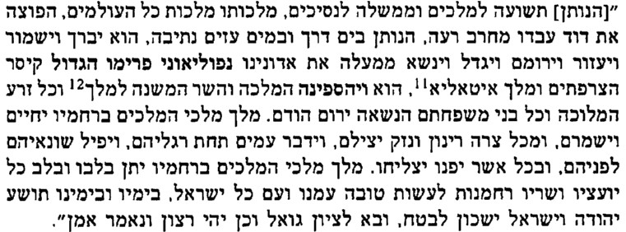
- אור המזרח חוברת כז (ממחזור לר"ה שנת תש"ג)
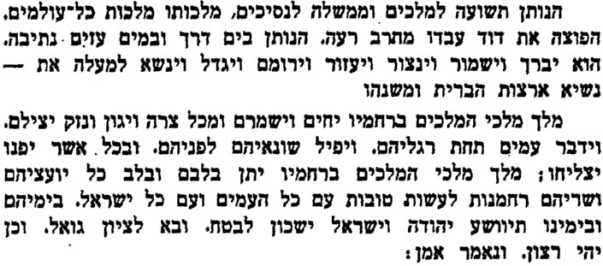
- לב העברי עמ' קט
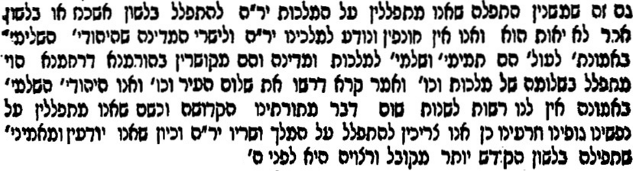
- כתר שם טוב עמ' תכ
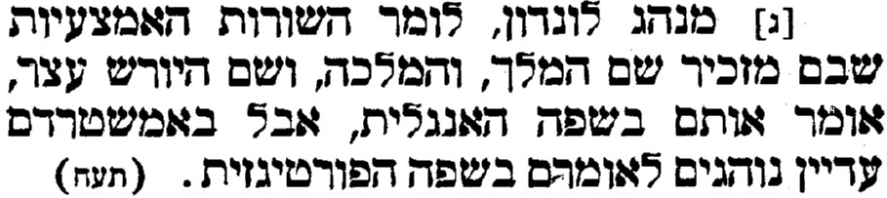
- מאירי ע"ז ד.
- מכתב סופר ס' א
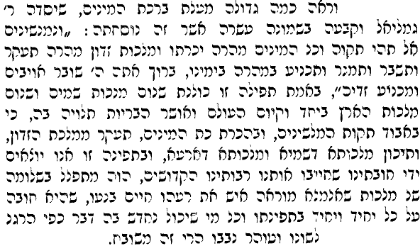
- קדוש ישראל עמ' קד
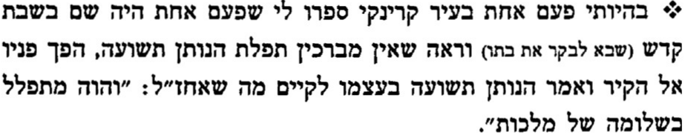
- הקדמה לים של שלמה
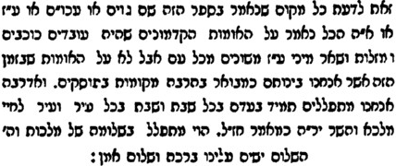
- תהלים קמד:י-יא
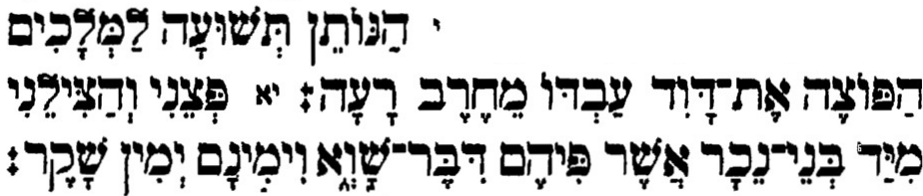
- ישעיה מג:טז-יז
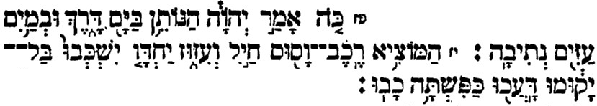
- כתבים של הרב יוסף קאפח ח"א עמ' תצב-תצג
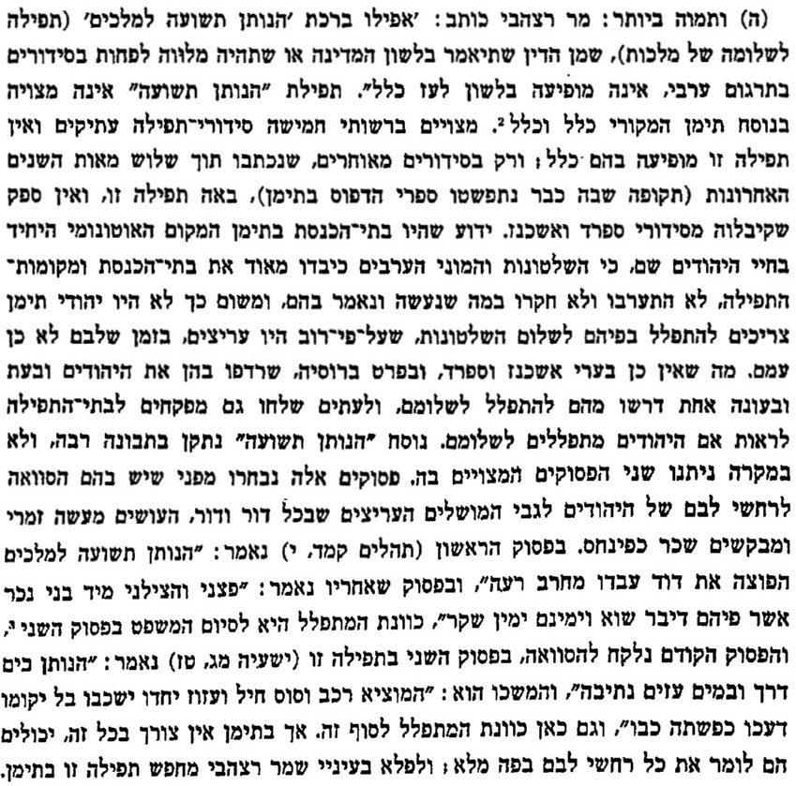
- ספר הזכרון של החתם סופר עמ' יד-טו
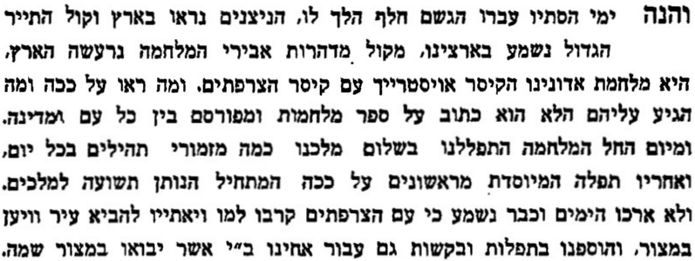
- עניני שבתי צבי עמ' נו
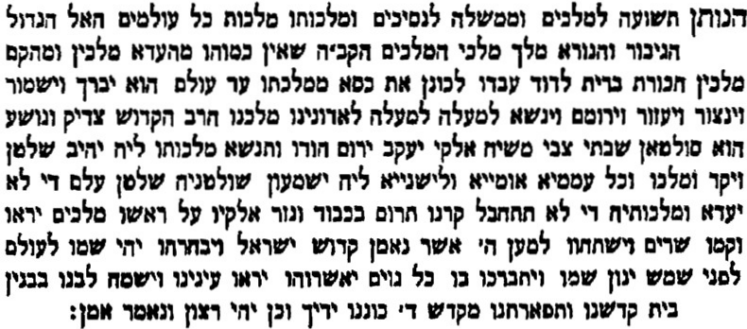
- חלקת יעקב חלק ב' (תולדות החלק"י) עמ' שט
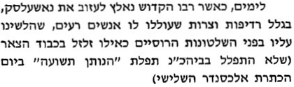
- חצר כולל גליציה עמ' ל
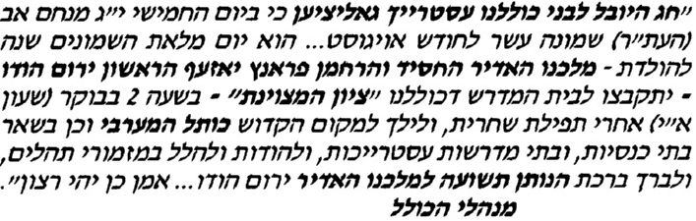

מתוך ספר מן המקור

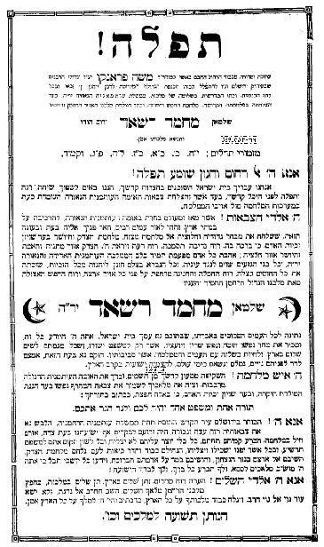

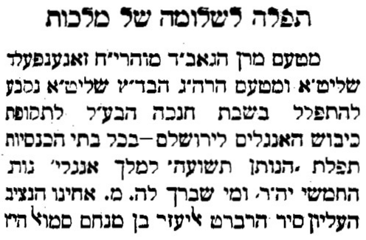
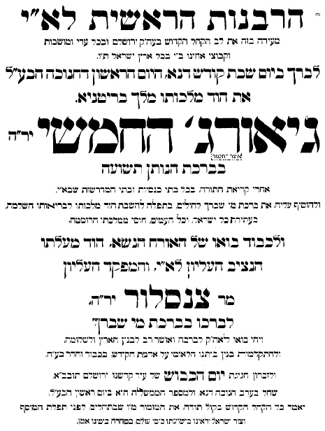

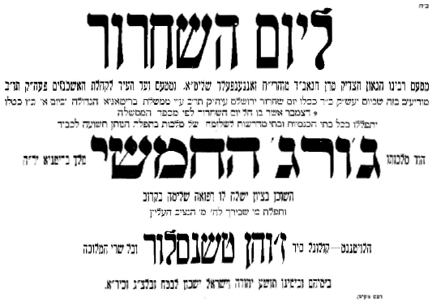

סדור השלום- מוסקובה תשט"ז



